Steering Wheel Switch Keep Alive Control Function– CGEA1.3

Functional Description

The Steering Wheel Switch Keep Alive Control Function is used by the IPC to request steering wheel switch input when required by the IPC HMI. IPC will start to request steering wheel switch input upon transition of Operational Mode to Normal/Crank. The IPC will continue to request steering wheel switch input when Operation Mode transitions to Limited Mode for as long as the IPC requires steering wheel switch input (ex. Ask on Exit for Perimeter Alarm). Since the IPC uses a wakeup signal to request steering wheel switch input, the IPC can send the request at any time.

The Steering Wheel Switch Keep Alive Control Function correlates the Operational_Mode and the X_Switch_Status_Flags to determine when switch input is required. X_Switch_Status_Flags will be set by each of the IPC STSS’s that require switch input in Limited Mode. The Steering_Wheel_Switch_Keep_Alive_Cfg bit will be set at EOL based on the capability of the module that Tx the steering wheel switch CAN signals.

Interfaces

Interface Context Diagram (I/O Block Diagram)

Steering Wheel Switch Keep Alive Control Function Context Diagram
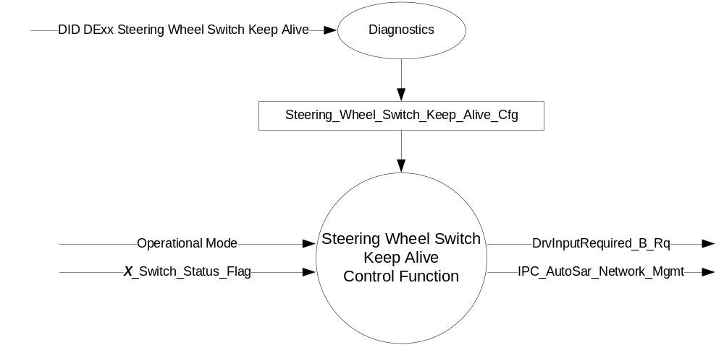

Inputs

      - Operational_Mode
      - Steering_Wheel_Switch_Keep_Alive_Cfg
      - X_Switch_Status_Flag

Outputs

- CAN Signal

- DrvInputRequired_B_Rq Signal
Signal Name | Size  (bits) | Detail | Units | Res. | Offset | State  Encoded | Min | Max
DrvInputRequired_B_Rq | 2 |  | SED | 1 | 0 |  | 0 (0x0) | 1 (0x1)
 |  | No |  |  |  | 0x0
 |  | Yes |  |  |  | 0x1

- IPC_AutoSar_Network_Mgmt (HS_CAN) Signal
Signal Name | Size (bits) | Detail | Units | Res. | Offset | State  Encoded | Min | Max
IPC_AutoSar_Network_Mgmt | 64 |  | Unitless | 1 | 0 |  | 0 (0x0) | 1.84467E+19

Function/Performance

Operational Modes

Mode | Differentiating Vehicle Conditions
Sleep Mode | No
Limited Mode | No/Yes
Normal Mode | No/Yes
Crank Mode | No/Yes

Voltage Levels

Refer to the Cluster Features Table located in the Operational Modes and Voltage Range Strategies of this SPSS.

Human-Machine Interface

Visual

Indicator Graphics / Display Format
Not Applicable.

Indicator Color Coordinates

Not Applicable.

Indicator Characteristics

Not Applicable.

Audio

Not Applicable.

Switch Control Logic

Not Applicable.

System Accuracy

Within a 100msec of receiving a message that results in a change of state the cluster will update the output to the proper status.

Operation: Performance and Functional

Subsystem Algorithm Flowchart / State Diagram

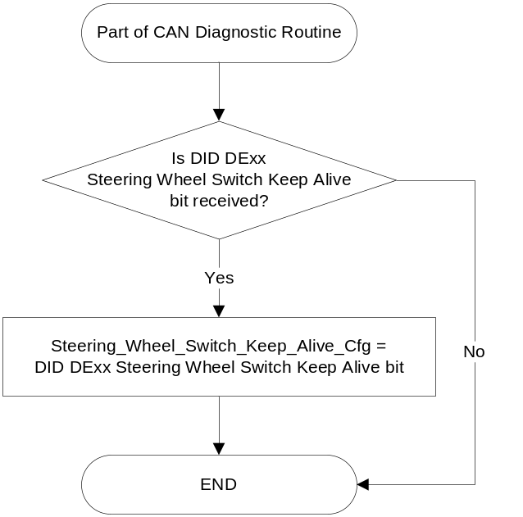

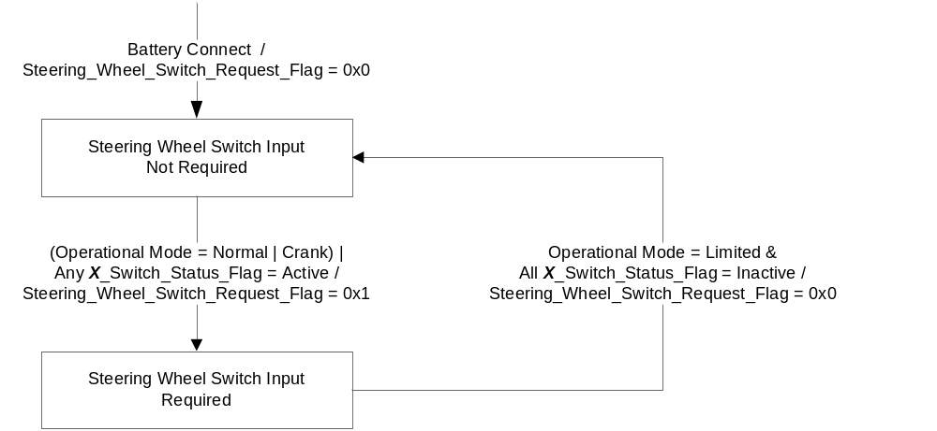

- DrvInputRequired_B_Rq and IPC_AutoSar_Network_Mgmt based on Steering_Wheel_Switch_Request_Flag
Operational_  Mode | Steering_Wheel_Switch_  Keep_Alive_Cfg | Steering_Wheel_Switch_  Request_Flag | DrvInputRequired_B_Rq | IPC_AutoSar_  Network_Mgmt
Limited | 0x1 (Autosar NM Proxy) | 0x1 (Active) | 0x0 (No) | 0xFE
X | 0x2 (CAN Signal) | 0x1 (Active) | 0x1 (Yes) | Per Network Management
All other cases |  |  | 0x0 (No) | Per Network Management

Note: DrvInputRequired_B_Rq is a local sleep inhibitor. The IPC must Tx DrvInputRequired_B_Rq = 0x0 (No) for at least 5 seconds and as long as AutoSAR NM messages are present before sleep is allowed (see Operational Modes and Voltage Range Strategies - CGEA1.3_vX.X STSS).

Operation Description (supports algorithm flowchart /state diagram)

The Steering Wheel Switch Keep Alive Control Function is used by the IPC to request steering wheel switch input when required by the HMI. The use of Autosar NM Proxy was intended to be a short term ICA. PCA uses a CAN signal to request the Steering Wheel Switch input. The Steering_Wheel_Switch_Keep_Alive_Cfg bit will be set at EOL based on the capability of the module that Tx the steering wheel switch CAN signals.

- For carryover programs where the IPC uses the NM Proxy to keep the SCCM awake at key off, the IPC will transmit DrvInputRequired_B_Rq = 0x0 and the SCCM will follow the NM Proxy.
- For new programs starting with B479, the IPC will transmit DrvInputRequired_B_Rq = 0x1 when the IPC requires steering wheel switch input in Limited Mode. IPC will start to transmit DrvInputRequired_B_Rq = 0x1 on transition of Operational Mode to Normal/Crank. The IPC will continue to send DrvInputRequired_B_Rq = 0x1 when Operation Mode transitions to Limited Mode for as long as the IPC requires steering wheel switch input (ex. Ask on Exit for Perimeter Alarm).
- Since multiple STSS’s can require the Steering Wheel Switch input at different times, X_Switch_Status_Flags will be set by each of the IPC STSS’s that require switch input in Limited Mode.
- DrvInputRequired_B_Rq is a wakeup signal and the IPC can send DrvInputRequired_B_Rq = 0x1 at any time to request steering wheel switch input.

The Autosar NM Proxy is byte 5 within the Autosar NM message that the IPC transmits (reference Smart DLC Central Gateway Functional Specification v1.4 or newer, Section 2, page 11). Each program has its own Smart DLC Central Gateway Program Configuration Specification. This specification will define the GENy Channel Reference for each network in the FlexCAN H/W Configuration Table. Section 2.5 Network Management Gateway Configuration will provide the Bit Position Chart from which the Channel alignment can be determined.

As an example, the GENy Channel Reference for HS2 is ChA per the FlexCAN H/W Configuration Table.

The Bit Position Chart from Section 2.5 provides:
7 | 6 | 5 | 4 | 3 | 2 | 1 | 0
x | x | x | x | ChD | ChC | ChB | ChA

Channel to Bit Position Alignment for the CD4 program:
7 | 6 | 5 | 4 | 3 | 2 | 1 | 0
x | x | x | x | HS3 | MS1 | HS1 | HS2

On CD4, the IPC is transmitting this proxy on HS3. To wakeup HS2, the IPC will transmit 1111 1110 = FE. 1 means sleep and 0 means awake per the spec referenced above. If the IPC does not need the other networks, then the IPC should set this message to all 0xFF.

Function Safety Classification (EMC)

B

Memory Storage

Parameter Name | Description | Value at Battery connect | Value at  Module Wake-up
Operational_Mode | Input to this routine that is a 4 State indicator for cluster operational mode | As per Operational Modes and Voltage Range Strategies Section (STSS) | As per Operational Modes and Voltage Range Strategies Section (STSS)
Steering_Wheel_Switch_Keep_Alive_Cfg | State Indicator for feature presence controlled via CAN at EOL at VO plant. | Use Stored Value | Use Stored Value
X_Switch_Status_Flag | Status flag indicating Steering Wheel Switch is required for Feature X | Per Feature X Control Function STSS | Per Feature X Control Function STSS
Steering_Wheel_Switch_Request_Flag | Internal flag that is set to 0x1 (Active) whenever steering wheel switch input is required. | 0x0 (Inactive) | 0x0 (Inactive)
IPC_AutoSar_Network_Mgmt message | Network Management Proxy CAN message. | 1111 1111 | 1111 1111
DrvInputRequired_B_Rq | CAN signal | 0x0 (No) | 0x0 (No)

Prove Out

No

Reconfigurable Telltale

No

Message Center Msg

Reference displays in section 1.3.5.1.

Error Handling

Missing Message Strategy

None.

Diagnostics

Self Test

None.

Engineering Test Mode

None

Part II Performance

Supported Diagnostic Trouble Codes (DTCs)

None.

DID DExx
Block  Num | Block Description | State: Description | "0" | "1" | Default | Comments/Information
PACKETED BLOCKS
$xx | Option Content (B&A) | Steering Wheel Switch Keep Alive |  |  | 0x2 | Disabled means the feature is not present in the vehicle
 |  | 0x0 – Disable  0x1 - Autosar NM Proxy  0x2 - CAN Signal | Encoded | Encoded

Reference Specification

Revision History

SPSS Module Revision History
Revision Level | Name | Change Description | Date
1.0 | J. Gregoire | Initial Release | 5/8/2015
1.1 | J. Gregoire | Change highlighted in Blue  DrvInputRequired_B_Rq is a local sleep inhibitor.  Page 3 Section 1.3.5.1 – Delete “Operational Mode = Sleep” from path to Steering Wheel Switch Input Not Required.  Page 3 Table 1.2 – Add note indicating DrvInputRequired_B_Rq is a local sleep inhibitor. | 5/15/2015
1.2 | J. Gregoire | Change highlighted in Yellow  Peer Review by Scott Watkins  IPC_AutoSar_Network_Mgmt should only be set to 0xFE by this STSS when Operational Mode = Limited, otherwise it should follow the Network Management specification.  Page 3 Table 1.2 – Add column for Operational_Mode. | 5/2/2017

